1. **Click on Show hidden icon as shown below.**

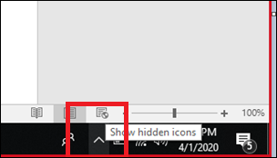

1. **Locate Checkpoint VPN Endpoint Security client icon and right click to view options.**

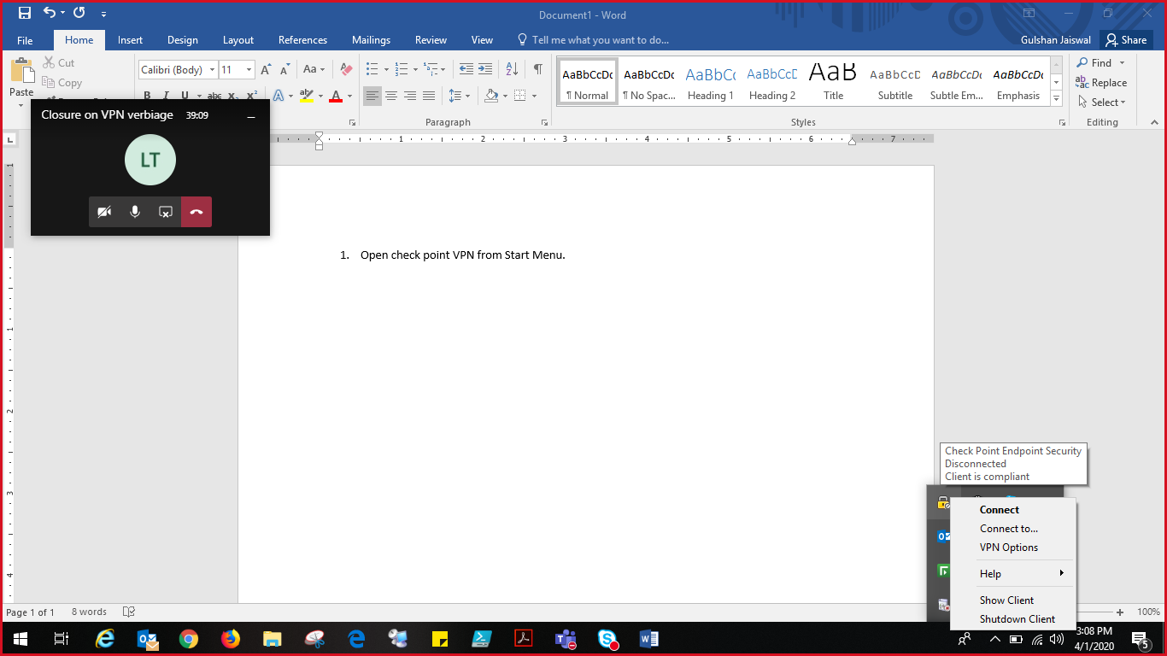

1. **Click Connect to and choose your current region from the drop down options. Below image is just for illustration only.**

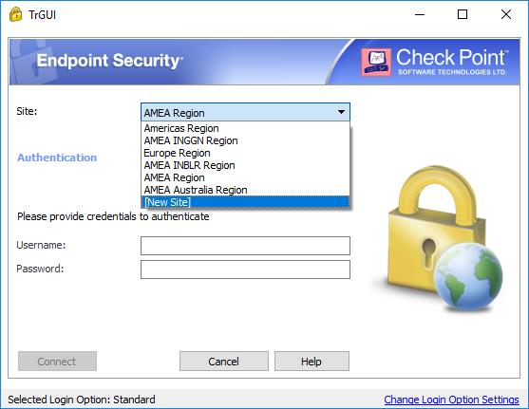

1. **Login with your LL ID and LL Password to connect VPN.**
2. **Provide Response code/OTP received on your registered mobile number and click Connect.**

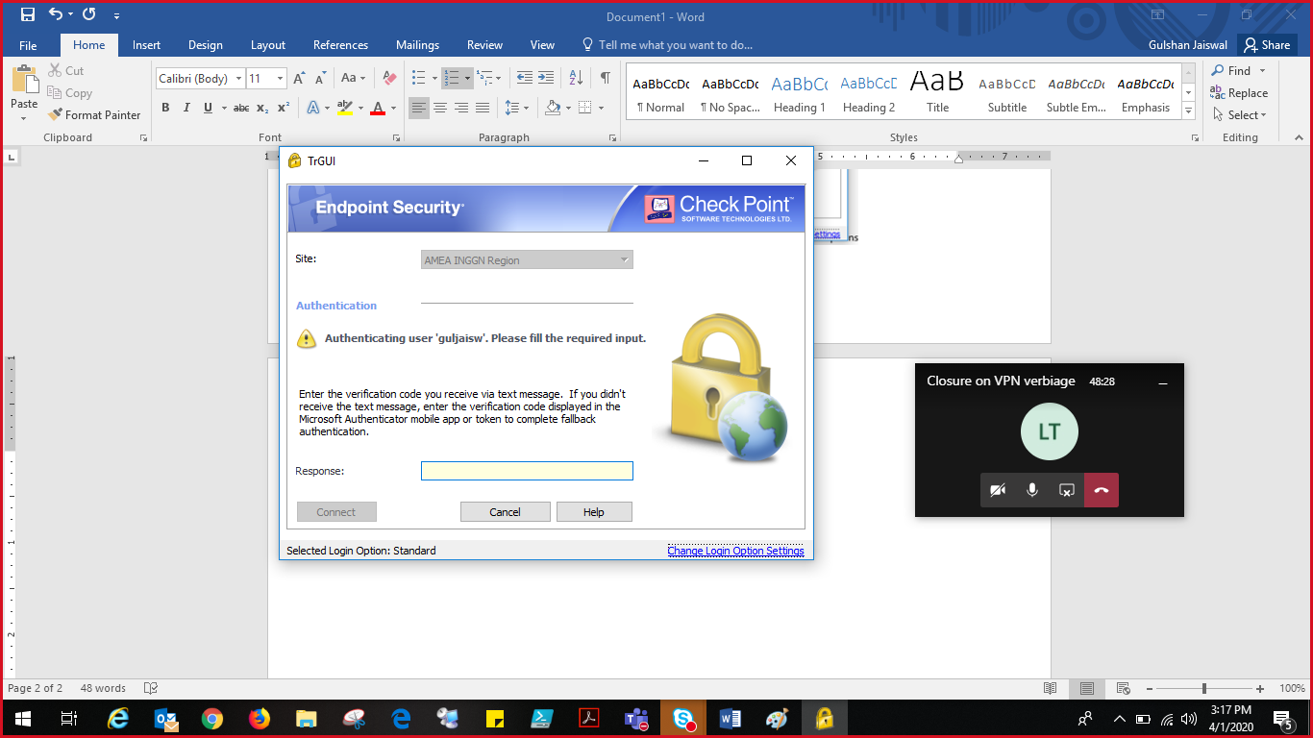

1. On successful connection, you will receive a POP-UP as shown below which confirms successful VPN connection.

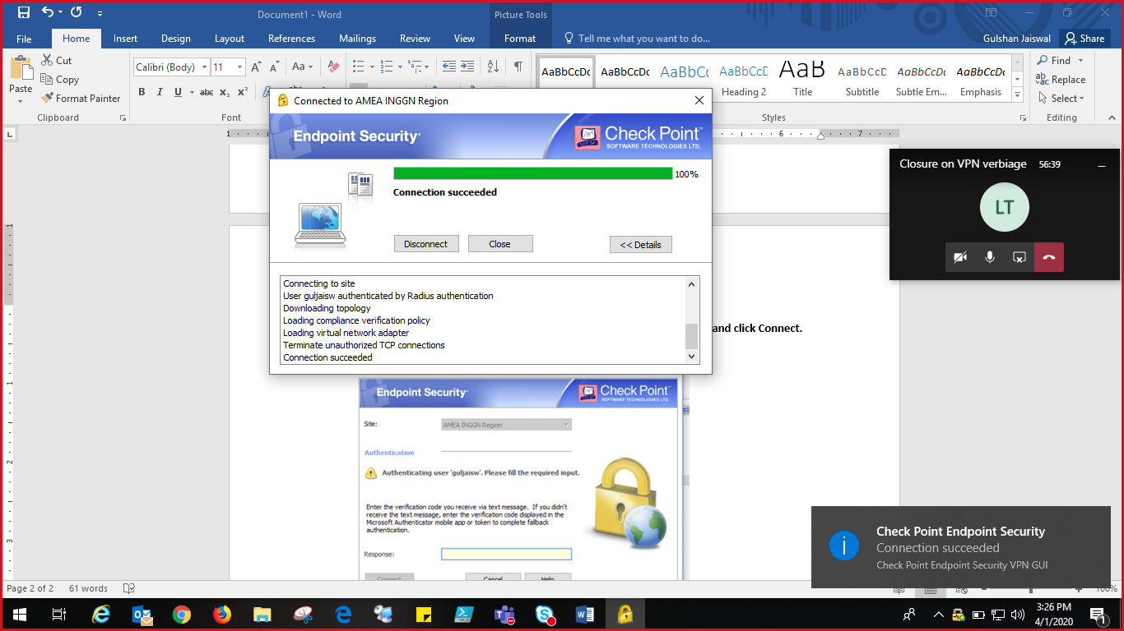

**Note : User must enroll for MFA before making a connection to VPN.**